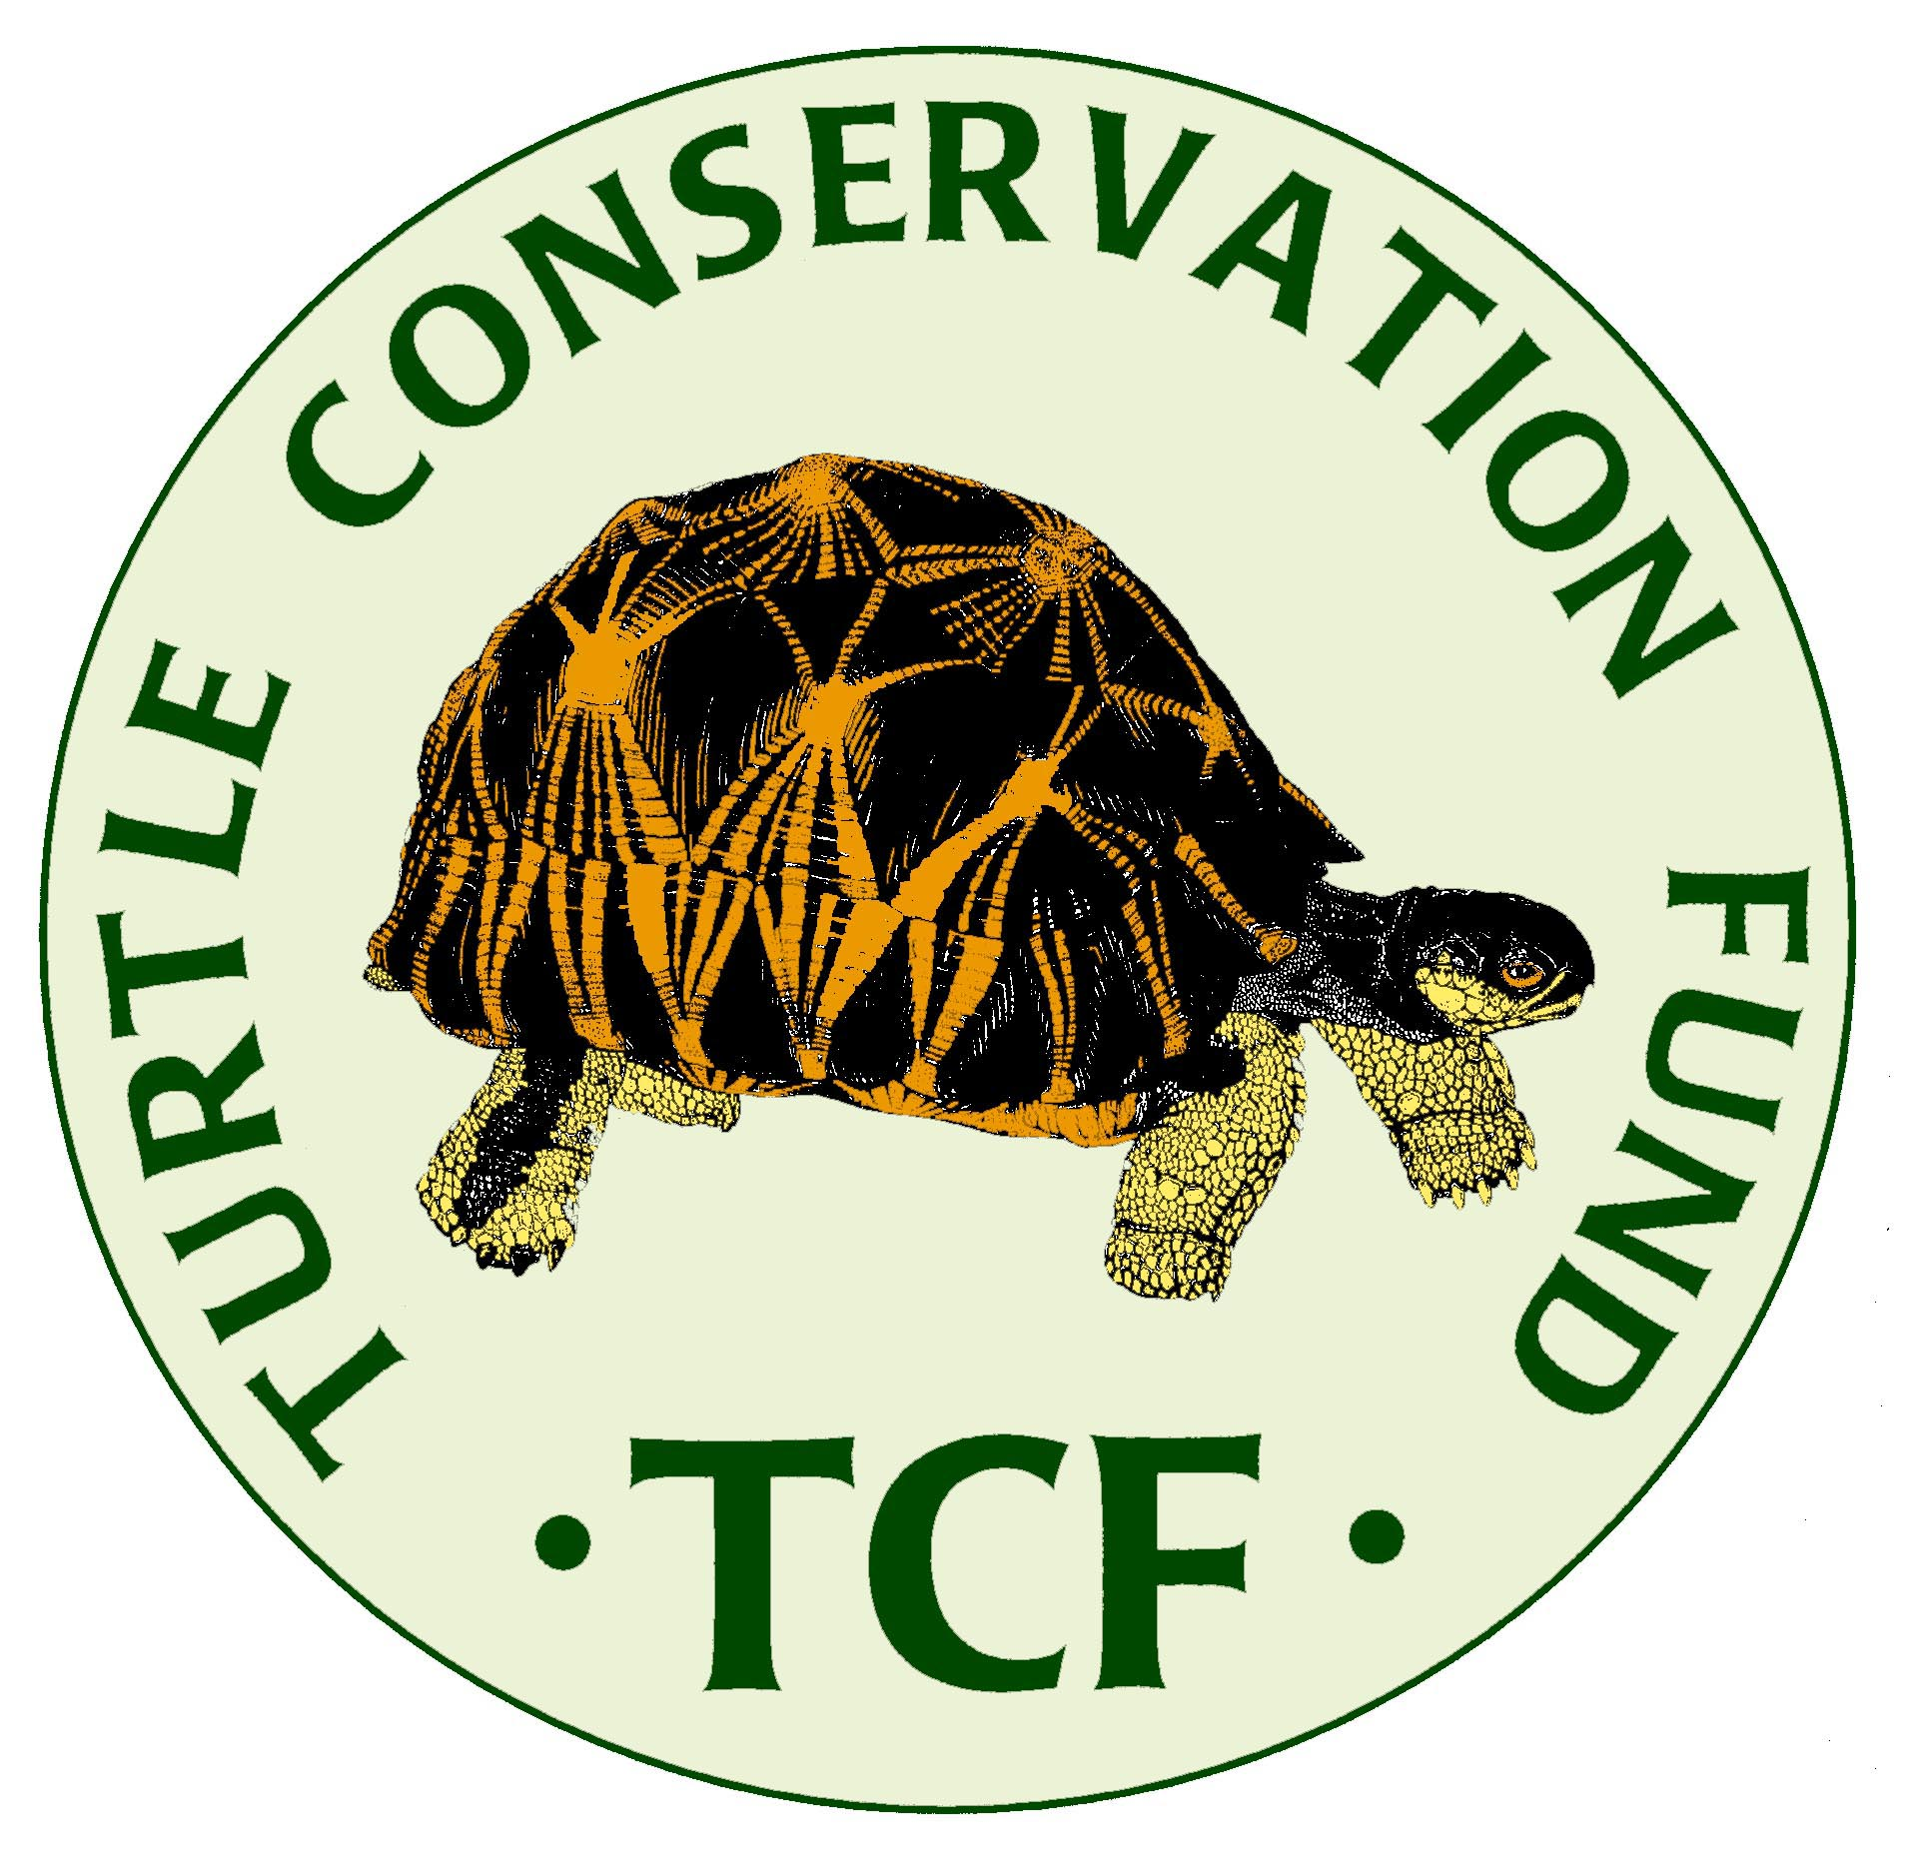

TURTLE CONSERVATION FUND
PROPOSAL TEMPLATE

The Turtle Conservation Fund (TCF), founded in 2002, awards grants twice a year to individuals or organizations for specific conservation or research projects focused
on tortoises or freshwater turtles, but not marine turtles,
with either partial or full support as funding allows.

• The maximum amount of each grant is US $5,000, focused on one of three categories of species in need of conservation action as outlined in point #5 below. Smaller grant requests of $3,000 or less are also encouraged to support pilot surveys or other conservation initiatives; they may also be provided to promote opportunities for younger emerging turtle conservationists from developing nations, including women and ethnic minorities with less prior experience.

• By submitting this application, and if funded, the proponents declare that all permits required to carry out the proposed project will be obtained as necessary, and that no work on the project will commence without the required permits.

• Further, the proponents declare that they and their project collaborators will conduct their studies with the sole goal of enhancing conservation of turtles, and will not collect, obtain, or distribute any turtles or other wildlife, whether live animals, parts or derivatives, for possession, transport, export, import, or sale, in breach of applicable national and international laws and regulations, during any phase of the supported project.

• The TCF provides grants in support of direct expenses for research and conservation of selected turtle projects and programs. TCF does not provide support for indirect organizational overhead expenses associated with administration of grants, and will not fund requests for such indirect costs.

• The proposal itself must use this template and should not exceed ca. 15 pages (excluding Literature Cited and C.V.’s). All type must be 12-point font. The inclusion of appropriate photos of the study species and study site as well as a map is encouraged, but the total proposal size needs to be kept under 5 MB.

Principal responsible investigator:
Name:______________________________ Institution:______________________________
E-Mail:_____________________________ Phone:__________________________________

Principal administrative contact person (if different):
Name:______________________________ Institution:______________________________
E-Mail:_____________________________ Phone:__________________________________
1. Proposed Project Title:

2. Name(s) of All Investigator(s) on the Project, with Institutional Affiliation(s)
and E-mail Addresses. Please identify the Principal Investigator(s):

3. Has the Principal Investigator received previous support from TCF?
If so, which projects were funded (TCF-numbers)____________________________
If so, are final reports due, and have they been submitted? ______

4. Funding Request
Total Project Budget $ ______
Funding Requested Specifically from TCF for this Project $ ____
Funding Requested from Other Sources for this Project
(list sources and amounts separately) Granted?
____________________________________ $__________ _____
____________________________________ $__________ _____
____________________________________ $__________ _____
____________________________________ $__________ _____
____________________________________ $__________ _____

Funding Already Granted from Other Sources for this Project $________
Funding Requested and Pending from Other Sources for this Project $________

5. Which of the following three species categories does your project address?
(Check the category that best describes the focus of your proposal)

_____a. species that are assessed as either Critically Endangered (CR) or Endangered (EN) on the IUCN Red List (see www.iucnredlist.org) or provisionally CR or EN by the IUCN Tortoise and Freshwater Turtle Specialist Group (see TTWG 2021 Turtles of the World Checklist and Atlas; www.iucn-tftsg.org/checklist/). These species are the primary focus for TCF.

_____b. species that are assessed as Data Deficient (DD) or Not Evaluated (NE) on the IUCN Red List (www.iucnredlist.org) or provisionally DD by the IUCN Tortoise and Freshwater Turtle Specialist Group (www.iucn-tftsg.org/checklist/). These species are an important focus for TCF.

_____c. species that have previously been assessed as LC, NT, or VU, but now have outdated IUCN or TFTSG Red List assessments (>10 years old) that specifically appear to need updating to reflect a significantly higher threatened level. Such projects need to provide a convincing rationale why the species’ conservation status may have changed and merits funding from the TCF. These species are a secondary but also important focus for TCF.

6. List the principal turtle species or taxa covered by your project:
Provide the current IUCN Red List Status for each species.
If different, also provide the TFTSG Provisional Red List Status for each species.

7. Geographic Location(s) of your Project:
(a map showing the site is welcome)

8. If your Project is located in a defined priority biodiversity region (e.g., hotspot or ecoregion), please list here:

9. If your Project involves an existing or proposed Protected Area (National Park, Wildlife Reserve, etc.), please list here:

10. Executive Summary:
(Provide a short summary of the project objective; maximum 300 words, shorter is better)

11. Background and research or conservation rationale:

a. For CR and EN species (category 5a), please summarize past and on-going conservation efforts focused on your proposed species or conservation site. Cite previous work.

b. For DD or NE species or those needing updated assessments (categories 5b, 5c), please provide a convincing rationale why the species warrants status evaluation investigations or why its current status (LC, NT, or VU) may need updating to reflect a higher threatened level.

12. Specific methodology:

a. For CR and EN species (category 5a), please describe the specific conservation efforts and their justification for the work that you are proposing for these species.

b. For DD or NE species or those needing updated assessments (categories 5b, 5c), please provide specific details on how your work will address the criteria needed for a revised IUCN Red List assessment (e.g., distribution, population status, relative abundance, past, present, and potential future threats, relevant demographic and natural history data, phylogeographic considerations, etc.). The proposal should indicate how the information to be collected would fill gaps in our knowledge of the conservation status of the species and how it would facilitate a revised assessment and the formulation of follow-up conservation projects.

13. Next Steps and Future Considerations:

a. For CR and EN species (category 5a), please discuss your vision for a longer-term conservation strategy for the species (for which the project may represent a component), and discuss how this may be achieved and who may be involved with this effort over the longer term.

b. For DD or NE species or those needing updated assessments (categories 5b, 5c), please indicate what the next steps you would recommend after a re-assessment has been accomplished. The objectives should be formulated so that their outcomes may be evaluated through concrete, verifiable short term indicators.

14. Project deliverables anticipated

a. For CR and EN species (category 5a), please discuss how your accomplishments may be measured in terms of successful outcomes.

b. For DD or NE species or those needing updated assessments (categories 5b, 5c), please indicate whether your work will lead to a revised IUCN Red List assessment or other measurable outcomes.

15. Proposed Budget Details
Please provide a specific breakdown of how the proposed TCF and other support would be
allocated.

16. General Timetable for Proposed Work

17. Literature Cited

18. C.V.’s for the Principal Investigator(s) only.
May incorporate here or submit as separate pdf or word doc files.

